**Creating Fields For Translists Object**

**Steps to Create a Field in an Object:**

1. While still on your salesforce account, navigate to the gear icon present in the top right corner. You will notice Setup and click on setup.
2. You will now be navigated to the setup page, and click on object manager and search for object “translists”.
3. Click on “Fields & Relationships” in the left panel.

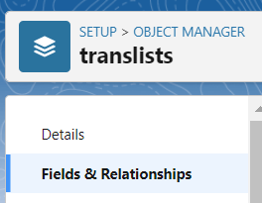

1. Click on New and choose the data type that is required by the field you need.
2. Click next and fill the following details in the mentioned.

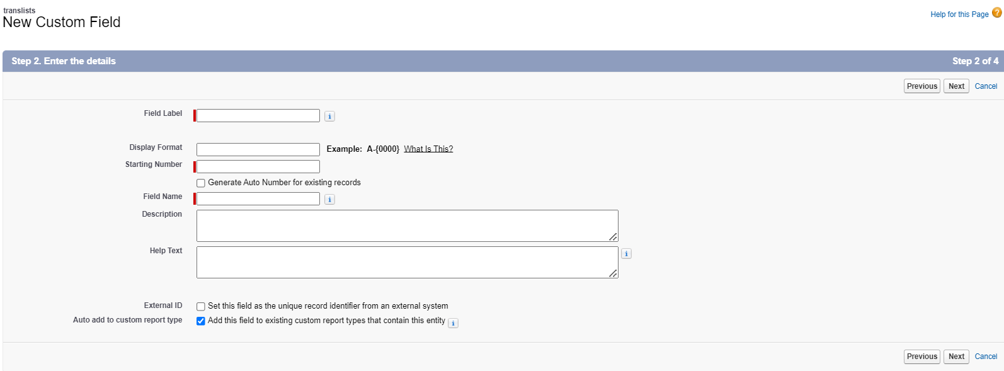

1. Click Next, Next and click on “Save and New”.

**Note :**Repeat the same steps to create the fields TransId, listname, ContactNo, Mailid, DateofTrans, subTot, discount, grandtot.

**Fields in Translists objects follow below data types:**

|  |  |  |
| --- | --- | --- |
| **S No** | **Field Label** | **Data Type** |
| 1 | TransId | Number(18,0) |
| 2 | listname | Text(25) |
| 3 | ContactNo | Phone |
| 4 | MailId | EMail |
| 5 | DateofTrans | Date |
| 6 | SubTot | Number(18,2) |

|  |  |  |
| --- | --- | --- |
| 7 | Discount | Number(18,0) |
| 8 | GrandTotal | Formula(Number(18,2)) |

**Lookup Relationship Fields :**

|  |  |  |
| --- | --- | --- |
| 1 | Itemrelated | Lookup(Items) |
| 2 | detailsofcustomer | Lookup(detailsofcustomer) |

**Formula Fields :**

Formula fields are custom fields that automatically provide results based on records and related records. They are a valuable and powerful tool provided by Salesforce to the Admins as they are updated automatically in real-time whenever a record is accessed.

In this project, GrandTotalfield uses formula field as a return type, where GrandTotal field is the total amount , after deduction of discount from total expense.

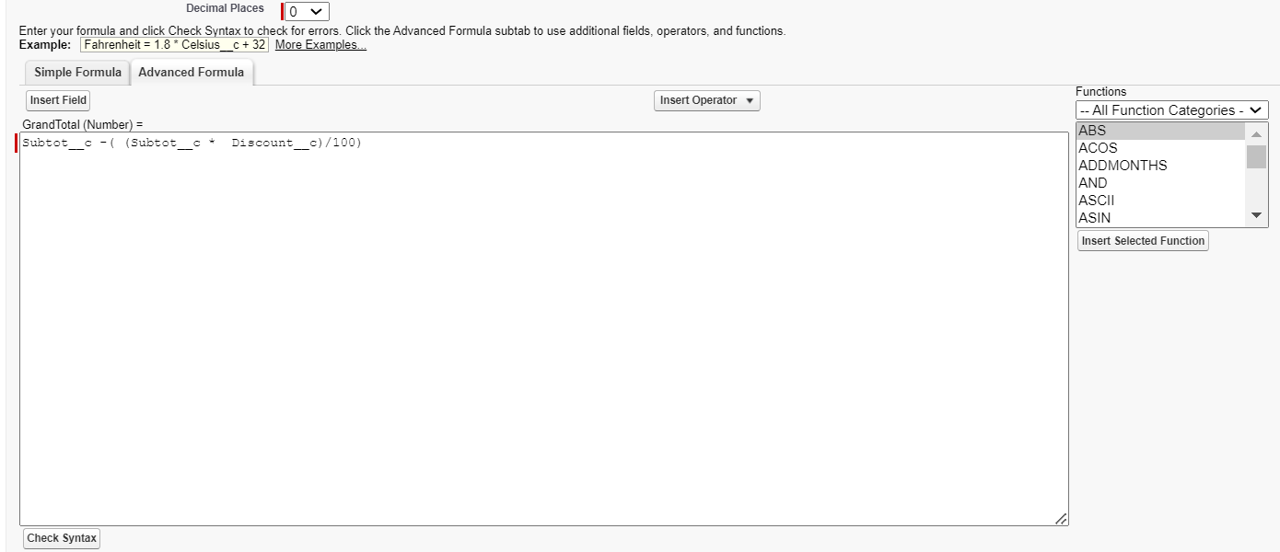

1. **Insert Operator : In this , we use arithmetic and logical operators like Add,Subtract, Multiply,Division, greater than, less tha, equals e.t.c.**
2. **Insert Field: Using this button, we get a list of all the fields of current object and we can use them in the formula.**
3. **Functions : It contains the basic functionalities which can be used in any formula field, such as ASCII, Today, Abs e.t.c.**